Object: Write a C program that will calculate the pay for employees

Program: Enter the Clock , Wage and Hours value as given below for 5 employee’s and get the Gross.

|  |  |  |
| --- | --- | --- |
| **Clock** | **Wage** | **Hours** |
| 98401 | 10.60 | 51.0 |
| 526488 | 9.75 | 42.5 |
| 765349 | 10.50 | 37.0 |
| 34645 | 12.25 | 45.0 |
| 127615 | 8.35 | 0.0 |

Input 1-

Loop value : INPUT



Employee1: INPUT-OUTPUT

|  |  |  |
| --- | --- | --- |
| 98401 | 10.60 | 51.0 |

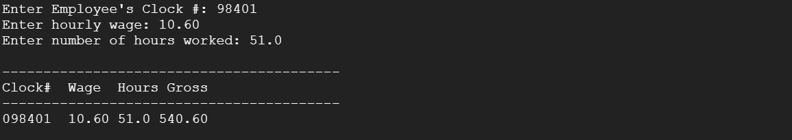

Employee 2: INPUT-OUTPUT

|  |  |  |
| --- | --- | --- |
| 526488 | 9.75 | 42.5 |

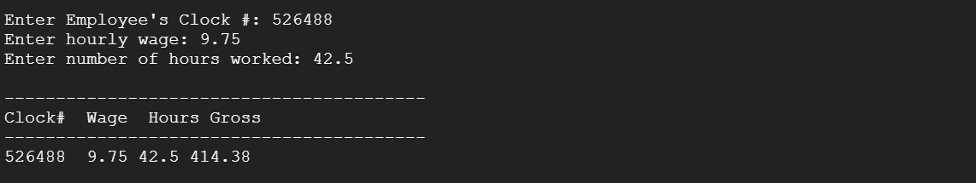

Employee 3: INPUT-OUTPUT

|  |  |  |
| --- | --- | --- |
| 765349 | 10.50 | 37.0 |

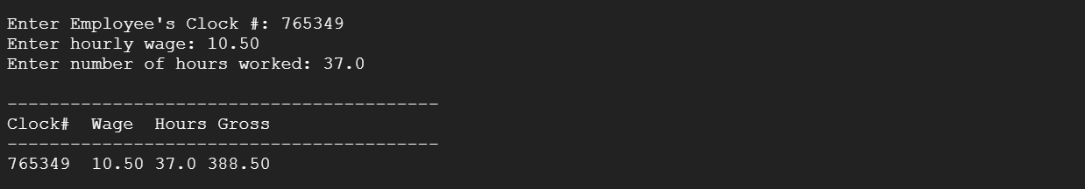

Employee 4: INPUT-OUTPUT

|  |  |  |
| --- | --- | --- |
| 34645 | 12.25 | 45.0 |

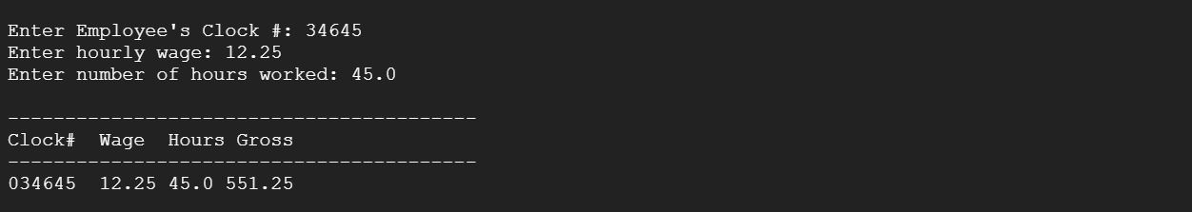

Employee 5: INPUT-OUTPUT

|  |  |  |
| --- | --- | --- |
| 127615 | 8.35 | 0.0 |

